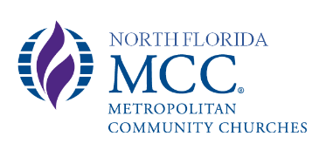
Leadership Representatives Meeting Minutes January 24, 2021

All Leadership Representatives present. Rev. Karla Dutey-Amburgey, Karen Kendall, Debbie Young, Gisselle King
Meeting called to order at 12:30 pm by Rev. Karla Dutey-Amburgey.

- Opening Prayer by Rev. Karla

- New Business:
  - Contracts/Covenants in place. (Karen)
    - Announced /Rev. Karla signed Pastor’s contract.
    - Reminded members of change to Leadership Representatives from Board of Directors as we represent our congregation.
    - Announced all Representative Leaders have signed Leadership Covenant making us accountable to each other and to the church.

  - 2020 End of Year Financial Report. (Debbie)
Presented Financial Report including attendance numbers, debits, credits and end balance. Debbie reminded us that the budget did not start until January. Gisselle asked for clarification regarding the number of services for each month in 2020 and how the numbers were counted (people who viewed during the service and were online for at least 3 minutes).
  - Outreach Opportunities (Gisselle)
Gisselle brought up helping out FirstCoast MCC by collecting items for their Blessing Bags. Motion to contact FirstCoast MCC and move forward as indicated by Karen; 2nd by Gisselle; Motion passed.
Karla brought up possibility of monthly outreach, starting immediately with donation to Rita in need of immediate funds. During course of discussion a donation to cover this amount was pledged so no action was needed. Following a lengthy discussion regarding regular outreach the decision was made to table further discussion until the February meeting.
- Closing Prayer by Karen at 1:15pm

Respectfully submitted: Board of Directors

