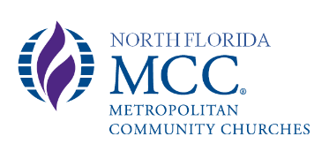
Special Congregational Meeting Minutes March 14, 2021

Virtual attendees: (via Zoom meeting)
- Betty Adams
- Dean Heaton
- Kim Williams
- Deb Young
- Sue DeLucia
- Brenda Roller (non-member/counter)

Call to Order at 12:35 pm

- Rev. Karla Dutey-Amburgey
- Karen Kendall
- Gisselle King
- Kathy Waite
- Kathy DeLucia

Opening prayer by Rev. Karla
20% required for Quorum. 10 in attendance. Quorum met.
Review of proposed CHANGE in bylaws.
Motion to approve change to Bylaws by Kathy Waite, 2nd by Kathy DeLucia. Motion passed.
Review of proposed ADDITION to bylaws.
Motion to approve addition to Bylaws by Kim, 2nd by Betty. Motion passed.
Closing Prayer by Karen
Meeting adjourned at 12:45 pm

Respectfully submitted: Gisselle King, Clerk

